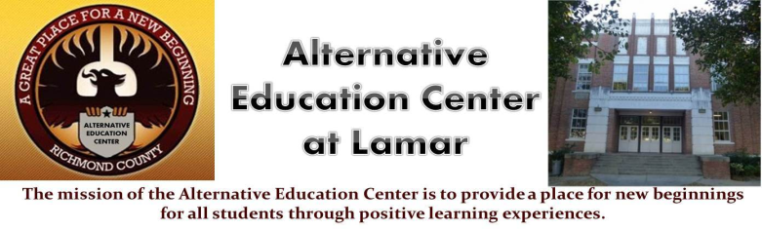**Alternative Education Center**

**Charles Givens- Principal**

Chauncey Scott – Asst. Principal

work Phone -706-796-4965 970 Baker Ave. Augusta, GA 30904

**Visitor Information**

**When visitors arrive at the Alternative Education School these are the following procedures.**

1. **Upon arrival the Visitor must enter through the 970 Baker Street front entrance.**
2. **The visitor must report to the main office.**
3. **The visitor must adhere to all school regulations.**
4. **The visitor must sign in before going to any place in the building or to see any personnel.**
5. **The Secretary or designee will give the visitor a yellow badge or pass to their destination.**
6. **Upon departure the visitor must sign out in the main office.**